# Report for Braden Dahlquist (2024-10-01 to 2024-10-31)

Average Bat Speed: 49.69

Average Rotational Acceleration: 7.80

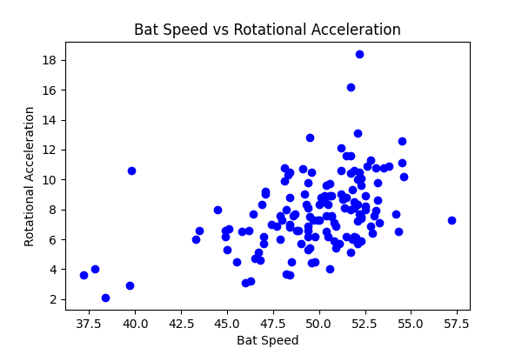

## Comments

Add comments here...